## **Check Virtualization Support**

1. Before you begin with installing KVM, check if your CPU supports hardware virtualization:

egrep -c '(vmx|svm)' /proc/cpuinfo

Check the number in the output:

egrep -c '(vmx|svm)' /proc/cpuinfo

IMG_256

If the command returns a value of **0**, your processor is not capable of running KVM. On the other hand, any other number means you can proceed with the installation.

2. Now, check if your system can use KVM acceleration by typing:

sudo kvm-ok

The output should look like this:

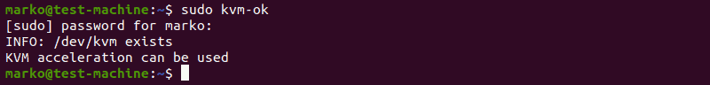

If **kvm-ok** returns an error stating KVM acceleration cannot be used, try solving the problem by installing cpu-checker.

3. To install cpu-checker, run the following command:

sudo apt install cpu-checker

4. When the installation completes, restart the terminal.

You are now ready to start installing KVM.

****Note:**** When it is performed for servers, hardware virtualization is referred to as [server virtualization](https://phoenixnap.com/kb/what-is-server-virtualization).

## **Install KVM on Ubuntu 20.04**

To enable KVM virtualization on Ubuntu 20.04:

* Install related packages [using apt](https://phoenixnap.com/kb/how-to-manage-packages-ubuntu-debian-apt-get)
* Authorize users to run VMs
* Verify that the installation was successful

### **Step 1: Install KVM Packages**

1. First, update the repositories:

sudo apt update

2. Then, install essential KVM packages with the following command:

sudo apt install qemu-kvm libvirt-daemon-system libvirt-clients bridge-utils

This will start the installation of four KVM packages:

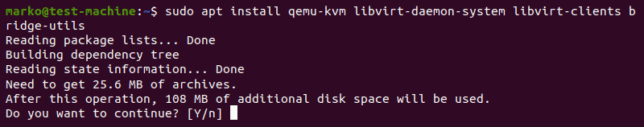

3. When prompted, type **Y**, press ****ENTER****, and wait for the installation to finish.

### **Step 2: Authorize Users**

1. Only members of the ****libvirt**** and ****kvm**** user groups can run virtual machines. Add a user to the libvirt group by typing:

sudo adduser ‘username’ libvirt (SEM AS ASPAS)

Replace username with the actual username.

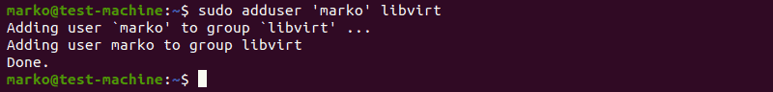

2. Now do the same for the kvm group:

sudo adduser ‘[username]’ kvm (SEM ASPAS E SEM COLCHETES)

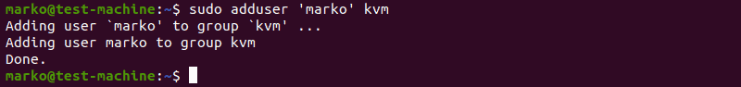

****Note:****If you need to remove a user from the libvirt or kvm group, just replace **adduser** with **deluser** in the command above.

### **Step 3: Verify the Installation**

1. Confirm the installation was successful by using the **virsh** command:

virsh list --all

You can expect an output as seen below:

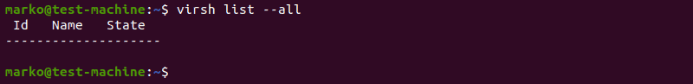

2. Or use the **systemctl** command to check the status of libvirtd:

sudo systemctl status libvirtd

If everything is functioning properly, the output returns an **active (running)** status.

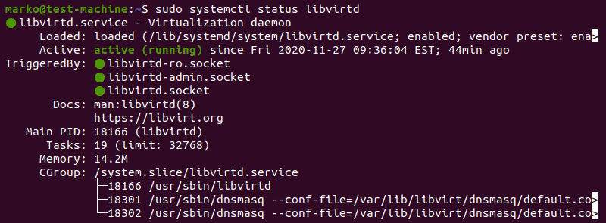

**ELE DEU UM ERRINHO AQUI, MAS SEM PROBLEMAS.**

3. Press **Q** to quit the status screen.

4. If the virtualization daemon is not active, activate it with the following command:

sudo systemctl enable --now libvirtd

sudo systemctl disable --now libvirtd

sudo systemctl start libvirtd

## **Creating a Virtual Machine on Ubuntu 20.04**

1. Before you choose one of the two methods listed below, install virt-manager, a tool for creating and managing VMs:

sudo apt install virt-manager

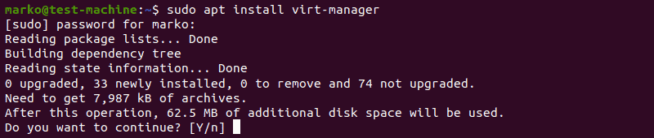

2. Type **Y** and press ****ENTER****. Wait for the installation to finish.

Make sure you download an ISO containing the OS you wish to install on a VM and proceed to pick an installation method.

### **Method 1: Virt Manager GUI**

1. Start virt-manager with:

sudo virt-manager

2. In the first window, click the computer icon in the upper-left corner.

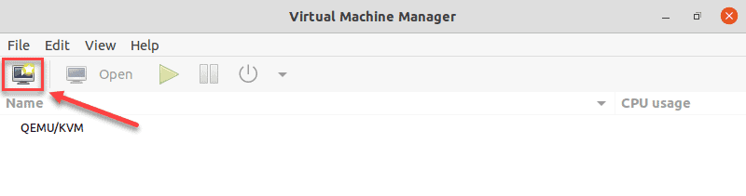

3. In the dialogue box that opens, select the option to install the VM using an ISO image. Then click ****Forward****.

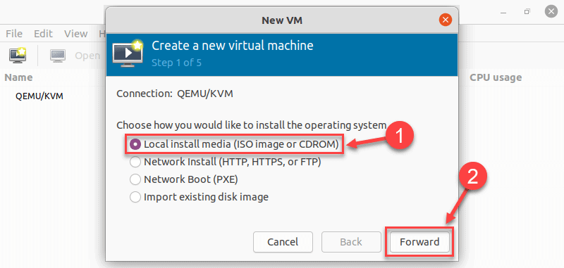

4. In the next dialogue, click ****Browse Local**** and navigate to the path where you stored the ISO you wish to install.

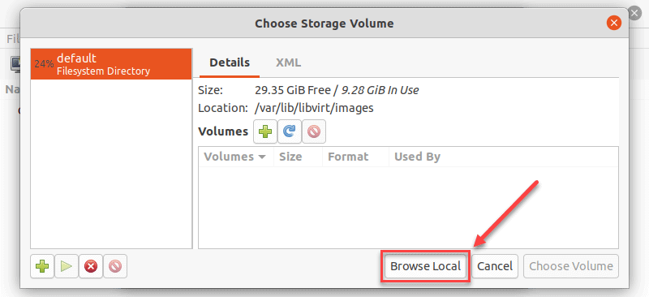

5. The ISO you chose in the previous window populates the field in Step 2. Proceed to Step 3 by clicking ****Forward****.

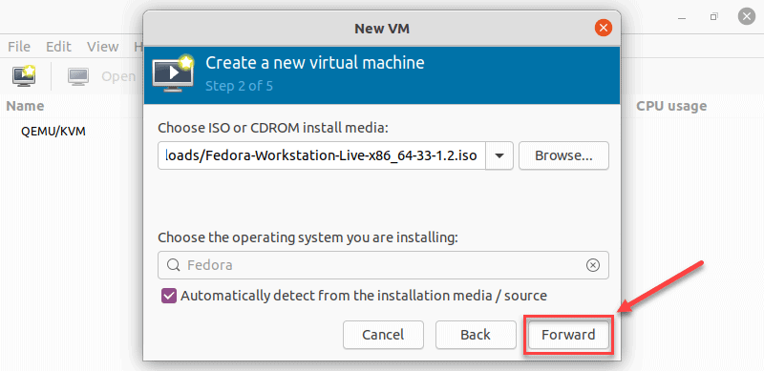

6. Enter the amount of RAM and the number of CPUs you wish to allocate to the VM and proceed to the next step.

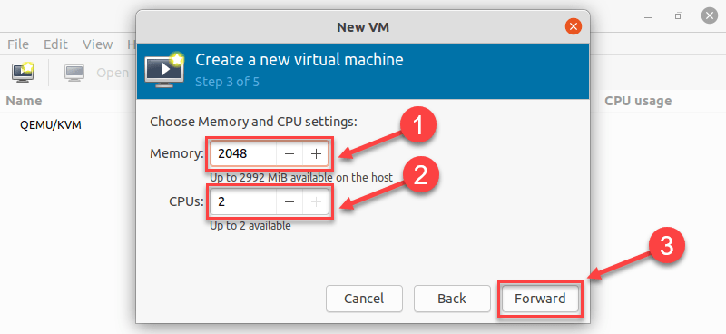

7. Allocate hard disk space to the VM. Click ****Forward**** to go to the last step.

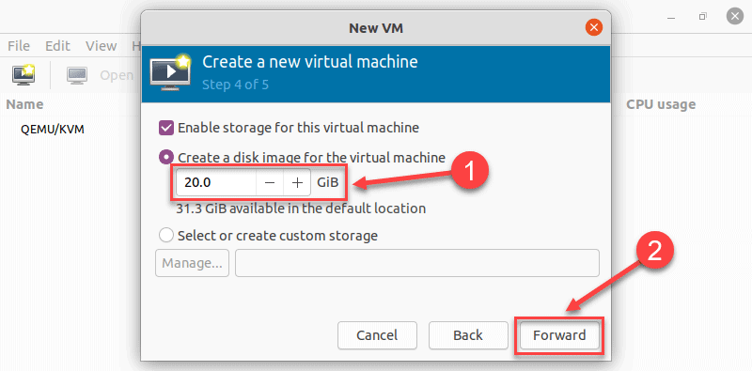

8. Specify the name for your VM and click ****Finish**** to complete the setup.

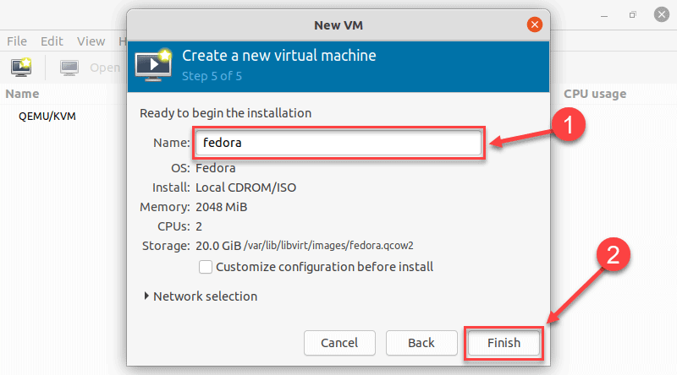

9. The VM starts automatically, prompting you to start installing the OS that’s on the ISO file.

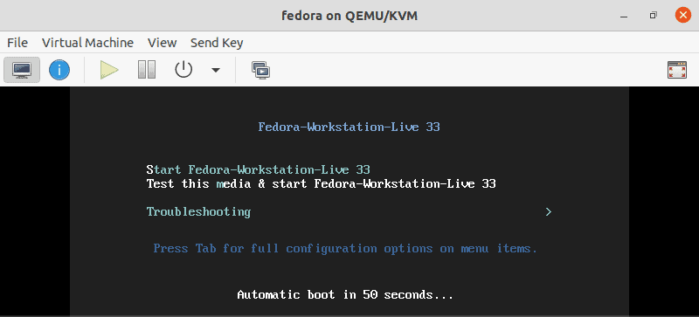

FONTE:

<https://phoenixnap.com/kb/ubuntu-install-kvm>